**Single Cycle CPU Design**

1. Here we have a single cycle CPU diagram. Answer the following questions:

a. Name each component. (3 points)

b. Name each datapath stage and explain its functionality. (5 points)

|  |  |
| --- | --- |
| Stage | Functionality |
| Instruction fetch | Send an address to the instruction memory.  Read the instruction(IMEM[PC]) |
| Decode/Register Read | Decode the instruction, use the register address to access the register group, and read the op number. |
| Execute | ALU Execute different operations and branch comparison. |
| Memory | This stage process load, store, and br inst. Read or write from memory. send the br address into PC |
| Register Write | Write the result into register[] |

c. Provide data inputs and control signals to the next PC logic. (3 points)



Inst[31:7]

Reg[rs2]

Reg[rs1]

Brcomp

Immsel

RegWriteEnable

PC+4

alu

IMEM

Inst[31:0]

Inst[11:7]

Inst[19:15]

Inst[24:20]

WBsel

Reg[]

DMem

MemRW

ALUsel

PC

PC sel

Fig. 1 Single Cycle RISC-V Datapath

**Single Cycle CPU Control Logic**

4. Fill out the values for the control signals from the previous CPU diagram. (8 points)

|  |  |  |  |  |  |  |  |  |  |  |
| --- | --- | --- | --- | --- | --- | --- | --- | --- | --- | --- |
| Instrs. | Control Signals | | | | | | | | | |
| BrEq | PCSel | ImmSel | BrUn | ASel | BSel | ALUSel | MemRW | RegWEn | WBSel |
| addi | X | Pc+4 | 1 | X | Reg | imm | Add | Read | 1 | ALU |
| and | X | Pc+4 | 0 | X | Reg | reg | And | Read | 1 | ALU |
| lw | X | Pc+4 | I | X | Reg | Imm | Add | read | 1 | MEM |
| sw | X | Pc+4 | I | X | Reg | Imm | Add | Write | 0 | X |
| beq | 1 | Alu | 0 | X | Pc | Imm | Add（怎么比较的？跳转是add） | X | 0 | X |
| jal | X | Alu | 0 | X | Pc | Imm | add | Read | 0 | PC+4 |
| jalr | X | Alu | 0 | X | Reg | imm | add | Read | 0 | PC+4 |
| Lui(load upper immediate.) | X | Pc+4 | 1 | 1 | Reg | Imm | Pass | Read | 1 | ALU |

(Put an X if the signal doesn’t matter)

**Clocking Methodology**

* The input signal to each state element must stabilize before each rising edge.
* Critical path: Longest delay path between state elements in the circuit.
* If we place registers in the critical path, we can shorten the period by reducing the amount of logic between registers.

**Single Cycle CPU Performance Analysis**

5. The delays of circuit elements are given as follows:

|  |  |  |  |  |  |
| --- | --- | --- | --- | --- | --- |
| Stage | IF | ID | EX | MEM | WB |
| Delay | 200 | 100 | 200 | 300 | 100 |

a. Mark the stages the following instructions use and calculate the time to execute. (8 points)

|  |  |  |  |  |  |  |
| --- | --- | --- | --- | --- | --- | --- |
| Instruction | IF | ID | EX | MEM | WB | Total |
| Delay | 200 | 100 | 200 | 300 | 100 | - |
| addi | X | X | X |  | X | 600 |
| and | X | X | X |  | X | 600 |
| lw | X | X | X | X | X | 900 |
| sw | X | X | X | X |  | 800 |
| beq | X | X | X |  |  | 500 |
| jal | X | X | X |  | X | 600 |
| jalr | X | X | X |  | X | 600 |
| lui | X | X | X |  |  | 500 |

b. Which instruction(s) exercises the critical path? (3 points)

load word , it needs to read from the memory and write to the register.

c. What is the fastest you could clock this single-cycle datapath? (3 points)

1/(900ps) = 1/(900*10^-12s) = 1.11*10^9 Hz = 1.11GHz

d. Why is a single cycle CPU inefficient? (3 points)

The instructions don’t parallelize. Every instruction has the same clock cycle time, so we have to clock to the slowest instruction. This instruction usually lw because it uses many components : instruction store, read register [], ALU, dataMEM, write back register[].

e. How can you improve its performance? (3 points)

use pipeline CPU, put registers between two stages so that we can make full use of each component in CPU.

6. A single cycle RISCV data path is illustrated in Fig. 1. Now we have the time information for each component tabulated in the Table below.

|  |  |  |  |  |  |  |  |  |
| --- | --- | --- | --- | --- | --- | --- | --- | --- |
| Element | Register clk-to-q | Register Setup | MUX | ALU | Mem Read | Mem Write | RegFile Read | RegFile Setup |
| Parameter | tclk-to-q | tsetup | tmux | tALU | tMEMread | tMEMwrite | tRFread | tRFsetup |
| Delay(ps) | 30 | 20 | 25 | 250 | 400 | 500 | 200 | 50 |

a. What’s the clock time and frequency of a single cycle CPU (ignore the branch comp and imm.)? (10 points)

25+30+20+250+400+500+200+50=1475ps

1/1475ps = 1*10^12/1475=677966100 = 677MHz

b. If the branch comp, imm., and the control need 50 ps, 100 ps, and 250 ps, respectively. Which instructions below needs longest processing time? Please explain. (12 points)

**addi, jalr, lui, lw, sw**

lw

because it needs mem read and mem write，it costs much time.

**Digital Circuit Design**

10. Create an XOR gate using only NAND gates. (6 points)

或非门 xor, 不同出1相同出0, y = (a’b’+ab)’ = (a’b’)’(ab)’ = (a+b)(a’+b’) = a’b +b’a =(( a’b + b’a)’)’加两个非 =(( a’b)’ ( b’a)’)’

11. How many different two-input logic gates can there be? How many n-input logic gates? (6 points)

Each input can be either 0 or 1, so we have 2^n input, output can be either 0 or 1, so we have 2^(n+1) n-input logic gates.

12. Draw an FSM for outputting a 1 whenever we have three repeating bits as the most recent bits, a 2 whenever we have 010 or 101, and a 0 otherwise. You may not need all states. (12 points)

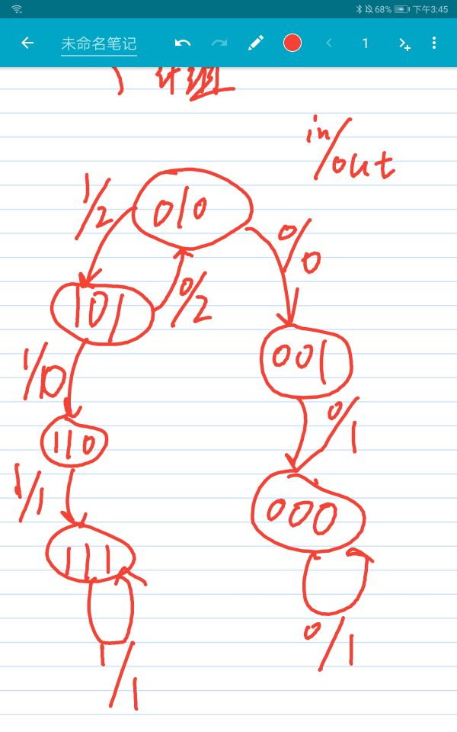

13. Fill out the timing diagram for the circuit below: (9 points)

+---+ +---+ +---+

IN-|D Q|-s0-|D Q|-s1-|D Q|--Out

+-^-+ +-^-+ +-^-+

| | |

CLK--+--------+--------+

clk

in

s0

s1 看s0前面是1

out

14. Fill out the timing diagram for the circuit below: (6 points)

+---+ +---+

A--|D Q|-R1-|D Q|-R2--

+-^-+ +-^-+

| |

CLK--+---|>o--+

clk

!clk

A

R1 看前面是1

R2